6.8 (a)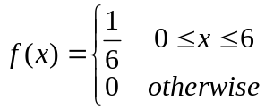
b. f(x)
1/6

0 6 min
c.
d.
e.
6.11 a. for 120 ≤ x ≤ 140
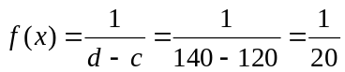
b. f(x)
1/20

120 140 min
c. P(125 ≤ x ≤ 135) = 10 (1/20) = .5
d. P(x ≥ 135) = 5 (1/20) = .25

6.36
Solve the two equations for the two unknowns: μ = 75, σ = 12

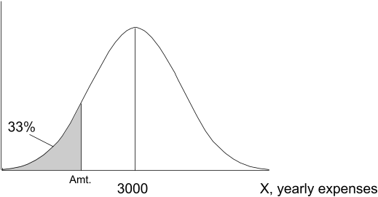
6.40 P(x ≤ k) = .33
k = 2780
$2780

6.49 a.
(approximately)
b. No

